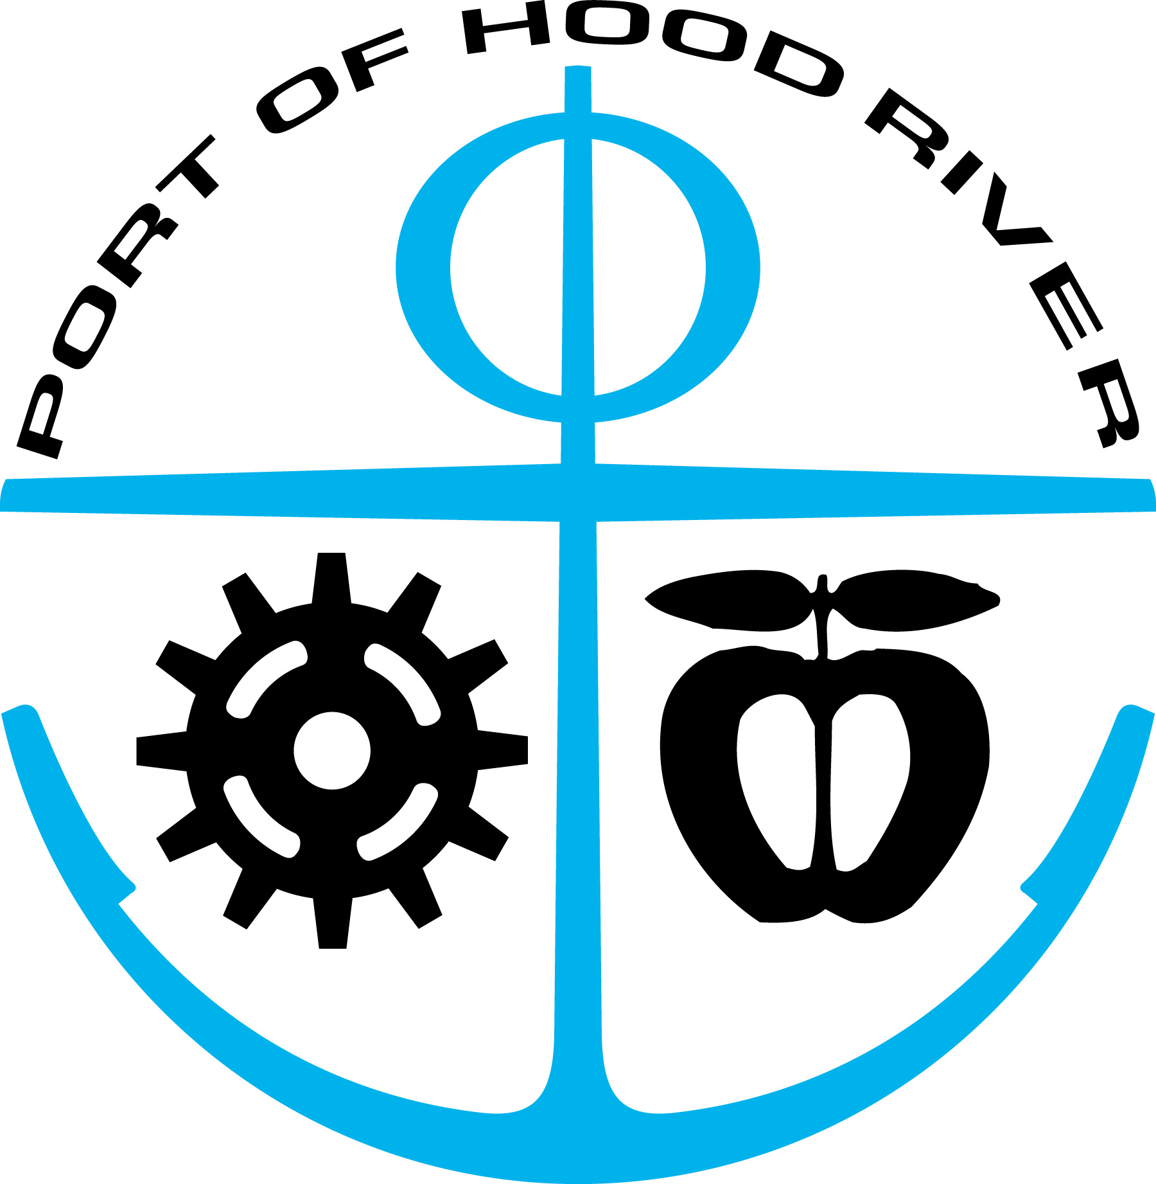
JOB TITLE: WATERFRONT COORDINATOR
WORKING TITLE: OFFICE ADMINISTRATOR/MARINA MANAGER
GENERAL EMPLOYEE • REGULAR • FULL TIME
SALARY RANGE: $22.48 - $30.12 PER HOUR
PREPARED: 3/1/2017

DEPARTMENT: | SUPERVISED BY: | FLSA STATUS:
Administration | Executive Director | Non-Exempt

JOB SUMMARY:
The Waterfront Coordinator is responsible for a wide variety of projects and tasks related to the Port’s recreational facilities. The position manages and implements waterfront-area programs, policies, and planning projects, serves as staff to Port committee(s) and advisory groups, acts as a liaison to schools and concessionaires, communicate with consultants, agencies and the public on waterfront recreation matters and monitors the condition of the Port’s recreation sites and recommends changes. The Waterfront Coordinator may assist with land planning, design, permitting and construction projects and make public presentations on Port matters. The position also has primary responsibility for facility management, tenant communication, lease administration, and compliance monitoring at the Hood River Marina and Ken Jernstedt Airfield. The position will assist with planning and implementation of capital and maintenance projects at both facilities. The position may provide occasional customer service and cash administrative functions related to bridge tolling and customer inquiries.

ESSENTIAL DUTIES:
- Waterfront Coordination: (Requires 50% of Time)
  - Staff support and coordination of the Waterfront Recreation Committee
  - Liaison to consultants, public agencies and the stakeholders on matters related to waterfront recreation
  - Establishes and maintains relationships with owner/operators of waterfront recreation schools and businesses
  - Administer food vendor concessions
  - Administer recreation schools concession agreements including school insurance, instructor qualifications, etc.
  - Monitors the condition of waterfront recreation sites and recommends repairs and upgrades
  - Manage or provide support for planning, policy, permitting and programmatic efforts which may include: Waterfront Access, Food Vendor Agreements, Request-for-Proposals, High Water Access Plans, Port Ordinance changes and Waterfront parking and signage plans.
  - Provide scheduling for Event Site parking booth attendants and assist in parking pass reporting.

• Marina and Airport Management: (Requires 50% of Time)
o Manages marina tenant moorage, Airport T-Hangar leases, including monitoring lease information and contracts and tenant files.
o Coordinates Marina Committee meetings, records and posts minutes.
o Conducts regular Marina “Dock Walks” to monitor electricity use, assess tenant compliance with lease terms and rules and regulations; and monitors the general condition of the marina docks for obvious maintenance needs.
o Communicates with Marina and Airport T-Hangar tenants about issues regarding lease and terms and conditions and coordinates annual lease renewals.
  - Manages the Marina Waiting List and Betterment List.
o Inspects with Fire Marshall Airport T-Hangars for compliance with Port policies.
NON-ESSENTIAL DUTIES:
- Occasional Staff support for Port committees and advisory groups.
- Provide occasional back-up support for customer service at the front counter.
- Assist in seasonal ticket booth scheduling and training.
SUPERVISION:
The Waterfront Coordinator works under the overall supervision of the Executive Director with oversight on financial transactions and bridge activities by the Chief Financial Officer. With regard to Marina management, rates, billings and evictions, the Waterfront Coordinator receives guidance from both the Chief Financial Officer and Executive Director. The Executive Director provides the annual review with input from the Chief Financial Officer. Guidance is communicated orally and/or in writing, and results are reviewed for accuracy and to assure use of proper methods.

SUPERVISORY RESPONSIBILITIES:
None.

MINIMUM QUALIFICATIONS:
- Education: Two-year degree with five years of administrative experience preferred or work experience in the current position can be used towards the educational requirement.
- Experience: Prior customer service, lease contract management, website management, and written/oral communications for public entity are preferred.
- Approvals: Must be bondable.
- Certifications: Possess and maintain a valid driver’s license with good driving record.
- Pass pre-employment background check

REQUIRED KNOWLEDGE, SKILLS, ABILITIES:
- Excellent telephone and “people” skills, as this position is often times a point of contact for the public interacting with the Port of Hood River.
- Excellent typing skills and proficiency in Microsoft Word, Excel, PowerPoint, Project Management software and other word processing, spreadsheet and website applications.
- Ability to take and transcribe meeting minutes.
- Excellent spelling, grammar and composition skills.
- Proficient in use of personal computer, 10-Key calculator, and other standard office machines.
- Attention to detail and a professional office manner.
- Cashier and some bookkeeping skills.
- Strong organizational and project management skills.

WORK ENVIRONMENT:
Typical office environment. Non-private office or desk. Occasional work out of doors on Port grounds. Occasional evening work required (i.e., attendance at Commission and other committee meetings.)

PHYSICAL DEMANDS:
Requires strength and mobility for this setting, including prolonged sitting and use of computer. Work occasionally requires lifting objects weighing a maximum of 35 pounds each, bending, and standing in one place for prolonged periods of time. Corrected vision sufficient for use of computers.

RELATIONSHIP WITH OTHERS:
The Waterfront Coordinator has regular telephone or in-person contact with employees of other departments, Bridge customers, Marina and Airport hangar tenants, external agencies, customers, vendors, and members of the general public to exchange information. Contact typically involves clarifying information, resolving discrepancies, negotiating the terms of contract agreements, enforcing compliance with rules and lease contract terms, and communicating Port policy on issues involving Bridge tolling, Marina moorage, and Airport hangar leases. Communication may be both oral and written.

SUPERVISOR SIGNATURE __________________________________________________

SUPERVISOR TITLE / DATE _________________________________________________

EXECUTIVE DIRECTOR SIGNATURE / DATE _____________________________________

EMPLOYEE SIGNATURE_____________________________________________________

EMPLOYEE TITLE / DATE ___________________________________________________

