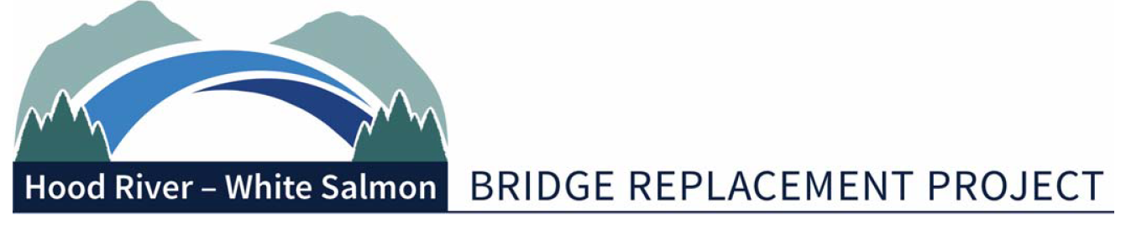
Bi-State Working Group Meeting Summary
Monday, August 9, 2021 | 2pm
Port of Hood River – via Zoom
1000 E Port Marina Drive, Hood River OR 97031
In Attendance:
Committee: Betty Barnes (Mayor), City of Bingen; Marla Keethler (Mayor), City of White Salmon; Kate McBride (Mayor), City of Hood River; Mike Fox (Commissioner), Port of Hood River; Jake Anderson (Commissioner), Klickitat County; Kristi Chapman (Commissioner), Port of Hood River - Alternate; Arthur Babitz (Commissioner), Hood River County – Alternate.

Consultants: Hal Hiemstra, Summit Strategies
Members of the Public: Miles Pengilly, Thorn Run Partners.
Staff: Michael McElwee, Executive Director; Kevin Greenwood, Bridge Replacement Project Director
Media: None.
Federal Infrastructure Funding Update
Hal Hiemstra provided an update on the federal infrastructure planning. The infrastructure bill is now known as the Infrastructure Investment and Jobs Act (IIJA). The IIJA is expected to be voted on by August 10 for a final vote in the Senate. Greenwood asked if programs such as BUILD have increased their funding. Hiemstra replied that some programs have had a plus-up. The RAISE program (new BUILD program) is one of the programs that had a plus-up. It will increase in the next 5-years by $7.5 billion. The INFRA program will also have an increase of $3.2 billion. Committee members requested a breakdown chart for the plus-ups.
Oregon Legislative Update
Miles Pengilly provided a brief update on the bi-state bridge authority. The Port decided not to move forward with the HB-3019 bill at the request of Rep. Susan McLain, Co-Chair of both the Joint Transportation Committee and Joint I-5 Bridge Committee. Rep. Mclain’s concern was that the conversations about a bi-state bridge authority for the Hood River Bridge, would become intertwined with ongoing debate between Oregon and Washington legislators about whether the I-5 bridge should be governed by a bi-state bridge authority. Pengilly provided recommendations for next steps in preparation for advancing bi-state bridge authority legislation during the 2022 legislative session.
Governance Legislation v. 2
Greenwood introduced the Joint Transportation Committee members. Greenwood briefly reviewed some of the changes to the Bi-State Commission Legislation draft. One of the changes was to make the legislation more general to allow similar type of bridges in Washington and Oregon to establish a bi-state bridge authority. Draft 3 is expected to be released by August 23.
Replacement Bridge Management Contract
Mike Fox presented his proposal for a Replacement Bridge Management Contract (RBMC). The RBMC team would be responsible for managing the project in its entirety, utilizing a team with technical expertise in project management, engineering contracting, scheduling, cost estimating, public information, and construction. This team would represent the owner’s interests in negotiations and reviews of the engineering and/or construction work. Michael McElwee recommended that staff create a finance plan to know what is available for this and other tasks. The committee consensus is to proceed with the RBMC approach.
NEPA Update
Greenwood noted that the term contract for Steve Siegel has ended. Greenwood is requesting consensus to extend the term through the end of January 2022 to complete Phase 2 governance work. The committee consensus was to extend Steve Siegel’s contract through January 2022.
Other Items
Brendan Conboy presented a proposal to conserve the existing Hood River Bridge. The existing bridge would be used for pedestrian and bicycle use only. Patrick’s recommendation is to conduct an economic and fiscal impact study on the existing bridge. Committee members agreed that the cost to maintain the existing bridge would not be feasible. Jake Anderson suggested that a piece of the bridge be used in the new park on the Washington side.
Adjourn
Meeting Adjourned.

-###-

