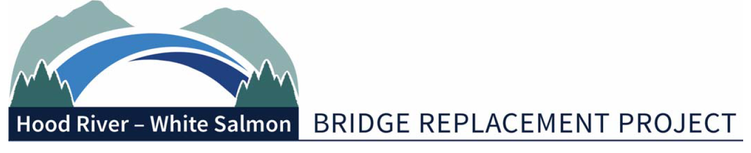
Bi-State Working Group Meeting Summary
Monday, September 13, 2021 | 2-4 p.m.
Port of Hood River – via Zoom
1000 E Port Marina Drive, Hood River OR 97031

In Attendance:
Committee: Betty Barnes (Mayor), City of Bingen; Kate McBride (Mayor), City of Hood River; Mike Fox (Commissioner), Port of Hood River; Bob Benton (Commissioner), Hood River County; Jake Anderson (Commissioner), Klickitat County
Alternates: Kristi Chapman (Commissioner), Port of Hood River; Arthur Babitz (Commissioner), Hood River County.
Consultants: Miles Pengilly, Thorn Run Partners; Brad Boswell, Boswell Consulting; Steve Siegel, Financial and Governance Consultant
Members of the Public: Dale Robins, SW Washington RTC
Staff: Michael McElwee, Executive Director; Kevin Greenwood, Bridge Replacement Project Director
Media: None.
Legislative Update
Brad Boswell provided a brief update on the Joint Transportation Committee (JTC). Last year's budget document requested that JTC do a study of what kind of statutory elements need to be included in any kind of Bi-State Bridge Authority. Steven Siegel has been working with outside consultants for the JTC and will be producing a final report that will then transfer to the internal legislative staff.
Boswell noted that they are trying to track the status of the $5 million that was allocated from last year's budget. There have been some contractual delays, but it is believed to be sitting in the Attorney General’s office awaiting review.
Commissioner Fox commented that the Bridge Replacement Management Contract (RBMC) will need funding by May-June of 2022. One of the first projects for RBMC is to write an RFP for a design contractor. The estimated cost to complete the contract is $40-$50 million. Boswell replied that that level of resource is going to be linked to a bigger transportation package, but he will do what he can.
Miles Pengilly provided an update on the Oregon side. The major obstacle for moving forward with the Bridge Authority legislation in 2022 was making sure they had buy-in from the co-chairs of the Oregon JTC. Pengilly met with Sen. Byer and Rep. McLain. Rep. McLain was receptive of doing a Hood River bridge authority that would not negatively impact conversations around I-5 bridge governance.
Washington Bridge Authority Legislation
Steve Siegel provided an update on the drafted bridge authority legislation. The bridge authority legislation is ready to be proposed. They are awaiting to hear from the lobbyists to proceed. The next phase is trying to get through legislation. Siegel recommended that the committee start working on reviewing drafts of the commission formation agreement.
Governance Progress
Bob Benton provided an overview of the structure of the Bi-State Working Group (BSWG) and their relationship with the Port board. To accelerate their efforts to replace the bridge, the BSWG is recommending streamlining and empowering citizen oversight of the process. The BSWG would have a member chair and co-chair from Oregon and Washington who set the agenda and run the BSWG meetings with staff support. The chair and co-chair would meet with the Port president regularly for updates. BSWG will consider this and decide at the next scheduled meeting if they would like to proceed with electing a chair and co-chair at that time.
WSP Preliminary Cost Estimate
Kevin Greenwood noted that the Port of Hood River Commission approved the WSP amendment and directed staff to monitor HB2017 expenditures and bring back other Port projects that could be delayed if necessary. The first meeting is tentatively scheduled for September 17. The agenda includes reviewing critical quantity items, high risk items, and assumptions.
Planning Level Post-NEPA Budget
Greenwood provided an overview of the planning level budget projections for post-NEPA, pre-construction expenditures and resources. Greenwood noted that there is not enough funding currently on hand and added that it is critical that they continue to perform on the funding that’s been granted.
Management Contract (RBMC) RFP
Greenwood noted that staff prepared an RFP using Commissioner Fox’s outline as guiding document. Staff added comments in the document for BSWG consideration. Staff are requesting feedback on the document before September 20, to prepare a final draft before submitting to legal. Commissioner Fox requested a work session to see how they are going to evaluate the bid.
July 17th Minutes
Commissioner Fox requested that the minutes be completed in a couple of days versus weeks. Greenwood said he would see what could be done. No additional changes were requested on the July 17 minutes.
Port Feedback
Greenwood noted that this item on the agenda is an opportunity for the BSWG to provide feedback to the Port. Commissioner Fox will provide a two-page document with items that would be tracked over the course of each year. Items would be reviewed as a group every six months and feedback would be sent back to the Port. The committee members will consider this and discuss it at the next meeting.
Adjourn:
Greenwood commented that the next meeting is scheduled for October 11.

