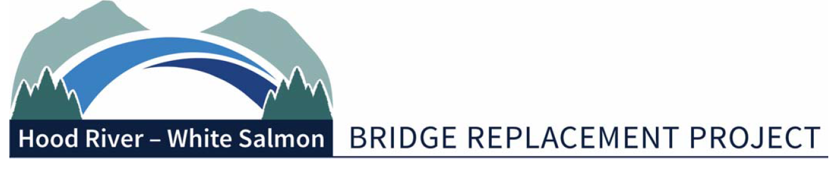
Bi-State Working Group Meeting Summary
Monday, February 14, 2022 | 2pm – 4pm
Port of Hood River – via Zoom
1000 E Port Marina Drive, Hood River OR 97031
In Attendance:
Members: Chair, Mike Fox (Commissioner), Port of Hood River; Catherine Kiewit (Mayor), City of Bingen; Kate McBride (Mayor), City of Hood River; Bob Benton (Commissioner), Hood River County. Excused: Vice Chair, Jake Anderson (Commissioner), Klickitat County; Marla Keethler (Mayor), City of White Salmon.

Alternates: Kristi Chapman (Commissioner), Port of Hood River; Arthur Babitz (Commissioner), Hood River County.

Staff/Consultants: Kevin Greenwood (Project Director), Port of Hood River; Michael McElwee (Executive Director), Port of Hood River; Miles Pengilly, Thorn Run Partners; Steve Siegel, Siegel Consulting; Brad Boswell and Jessica Hostetler, Boswell Consulting; Jen Meyer,Concept Jeneration LLC; Gordie Kelsey, Klickitat County; Sam Hunaidi and Rob Wattman, ODOT; Michael Williams, WSDOT.
Guests: Chuck Green and Scott Nettleton, Otak; Catherine Hovell, Michael Shannon, Heidi Johnson, Kary Witt, Brad Shinn and Phoebe Hyun, HNTB; Matt Ransom, SWRTC; Nate Stice, Oregon Governor’s Office.
Bi State Working Group Chairman, Mike Fox, opened the meeting and welcomed attendees.
January 17 Regular Meeting Minutes
The minutes from the January 17 regular meeting were approved by consensus.
Legislative Update – Brad Boswell and Miles Pengilly
Boswell noted the Washington democrat-led effort for a Transportation Plan this short session included a $75-million placeholder for the Hood River Bridge. This shows how much Sen. Curtis King is respected that a placeholder would be included. Will be difficult to get bi-partisan support for the bill. Cautioned to not publicize the funding until a bill in signed into law.
Washington SSB 5558 is moving through legislature. Bill passed Senate and is awaiting a hearing in House.
Pengilly gave update on Oregon Transportation Commission (OTC) hearing process. Letters of advocacy can be submitted to Greenwood for distribution to OTC administrator. Notice was given for participating in hearing on Thursday.
Oregon HB 4089-1 passed House last week and will be receiving full Senate vote this week. Upon passage, the bill will go to Governor’s desk for signature.
Bridge Sufficiency Rating
Commissioner Fox discussed a recent ODOT report that had reduced the Hood River Bridge’s sufficiency rating to below 20. This was a 30-point drop since 2018 and should be an important discussion point to demonstrate the urgency of bridge replacement. Commissioner Babitz indicated that he would research FHWA bridge ratings; Greenwood noted that he would send an email inquiring on state bridges.
Jen Mayer, Concept Jeneration LLC
Commissioner Fox turned to Jen Mayer from Concept Jeneration LLC for a presentation on P3s. Mayer discussed why and when you should undertake a P3. Mayer recommends that before proceeding with a P3 its best to identify key questions and get early indications before committing to a full-on study or seeking legal authority that would be required to do a P3.
Commissioner Benton asked Mayer what her takeaway was from the last meeting she attend with the BSWG. Mayer replied that in this environment she believes there are several P3 ventures that would be interested in this project and added that there could potentially be a better bidding environment than there has been in other cases.
Commissioner Fox noted that they need to try to minimize any toll increases regardless of which route they choose. Commissioner Fox asked how can they be assured that they would be setting aside enough money with a P3 to eventually replace the new bridge in the future. Mayer replied that most P3s during the availability payment period must put money into a reserve fund for maintenance. Before they hand over the bridge there is a requirement that they keep it in good condition. If the bridge is not in good condition, then they owe the public partner that money.
Commissioner Fox commented that they are in the final stages of finalizing the RFP for the Replacement Bridge Management Contract (RBMC). One of the first task for the RBMC is to draft an RFP for full design and there could be an off ramp at 30% where they can terminate the contract and switch over to a P3. Commissioner Fox asked if that was a good time to switch over to a P3 if needed. Mayer commented that she has seen it done the other way where you go down the path towards a P3 and you take the exit ramp towards public sector. Mayer believes either direction is reasonable, and added that an exit ramp at 30% is not too late to switch to a P3.
Commission Formation Agreement Process – S. Siegel
Greenwood commented that with the bi-state bridge authority legislation on a strong trajectory for passage, it was best to review the steps after the bill becomes law. A 2022 Governance Schedule was presented to provide an introduction of what is to come. Greenwood turned to Steve Siegel for a brief overview of the schedule. Siegel noted that the BSWG will need to develop Commission Formation Agreements (CFA) for local government adoption. There should be a fully functioning Commission by July 2024. Commissioner Fox requested a list of everything they need to have in place to go fully operational. Siegel replied that he would provide a list at the next meeting.
Memo on BSWG Authority
Greenwood noted that late last year, the BSWG asked about the nature of its authority. Jerry Jaques prepared a memo and presented it to the Port Commission and is now available to the BSWG for review. Commissioner Fox tabled this item for the next BSWG meeting for questions or comments.
RBMC RFP Update/Pre-Proposal Conference
Greenwood reported that he received comments from Bill Ohle and has an appointment with Melanie McMerrick from ODOT on Thursday for an RFP review. An example of an agenda for the Pre-Proposal Conference (PPC) was provided. Greenwood added that this is an opportunity for staff to give background on the project and ultimately get questions or clarifications from the industry that can then be released in an addendum to the RFP. This is also an opportunity for the BSWG members to engage with the industry and set out some expectations. Commissioner Fox suggested that the members pick what they want to be a part of and let Kevin Greenwood know by Friday 18.
Project Updates
Greenwood noted that Sec. 106 Consulting Parties meeting No.5 is coming up and an agenda was provided in the packet. House Bill 2017 funding is complete. Greenwood commented that he included a draft letter in the packet and asked if it was acceptable to send out time sensitive letters in support of funding or related to the bridge authority on short notice. There was group consensus to allow time sensitive letters to go out on short notice.
Adjourn
Next meeting is scheduled for March 14.

-###-

