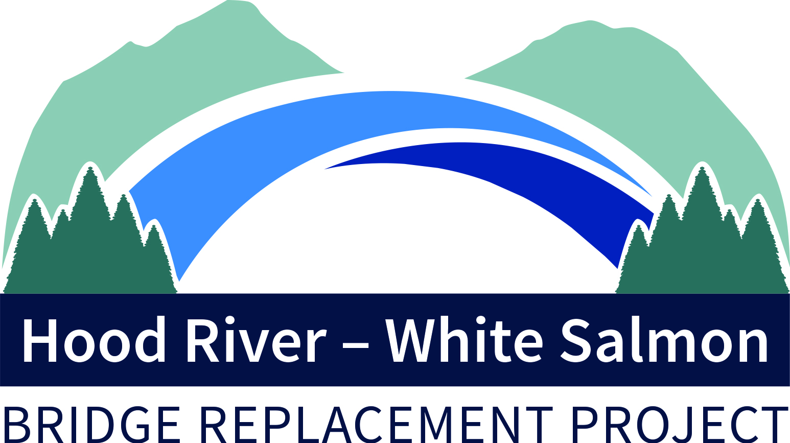
DRAFT AGENDA
Bi-State Bridge Replacement Working Group
Regular Meeting
May 13, 2022 / 2:30-4:00p (1.5 hours)
Via Zoom

Members: Chair, Mike Fox (Commissioner), Port of Hood River; Vice Chair, Jake Anderson (Commissioner), Klickitat County; Catherine Kiewit (Mayor), City of Bingen; Marla Keethler (Mayor), City of White Salmon; Kate McBride (Mayor), City of Hood River; Bob Benton (Commissioner), Hood River County

Alternates: Kristi Chapman (Commissioner), Port of Hood River; Arthur Babitz (Commissioner), Hood River County; Joe Sullivan, City of Bingen; Jason Hartmann (Councilor), City of White Salmon; David Sauter (Commissioner), Klickitat County; Jessica Metta (Councilor), City of Hood River.

Staff/Consultants: Kevin Greenwood (Project Director), Port of Hood River; Michael McElwee (Executive Director), Port of Hood River; Hal Hiemstra, Summit Strategies.

- Welcome 2:30
- April 11 Regular Meeting Minutes 2:31
- Federal Advocacy Trip, Hal Hiemstra 2:33
- Replacement Bridge Management Contract (RBMC) Recommendation 2:43
- RBMC Negotiation Schedule 2:53
- Project Updates/Other Items 3:30
- Next Meeting, June 20, 2022 3:35

-###-

Contact Kevin Greenwood, (541) 961-9517 or kgreenwood@portofhoodriver.com,
for Zoom credentials

