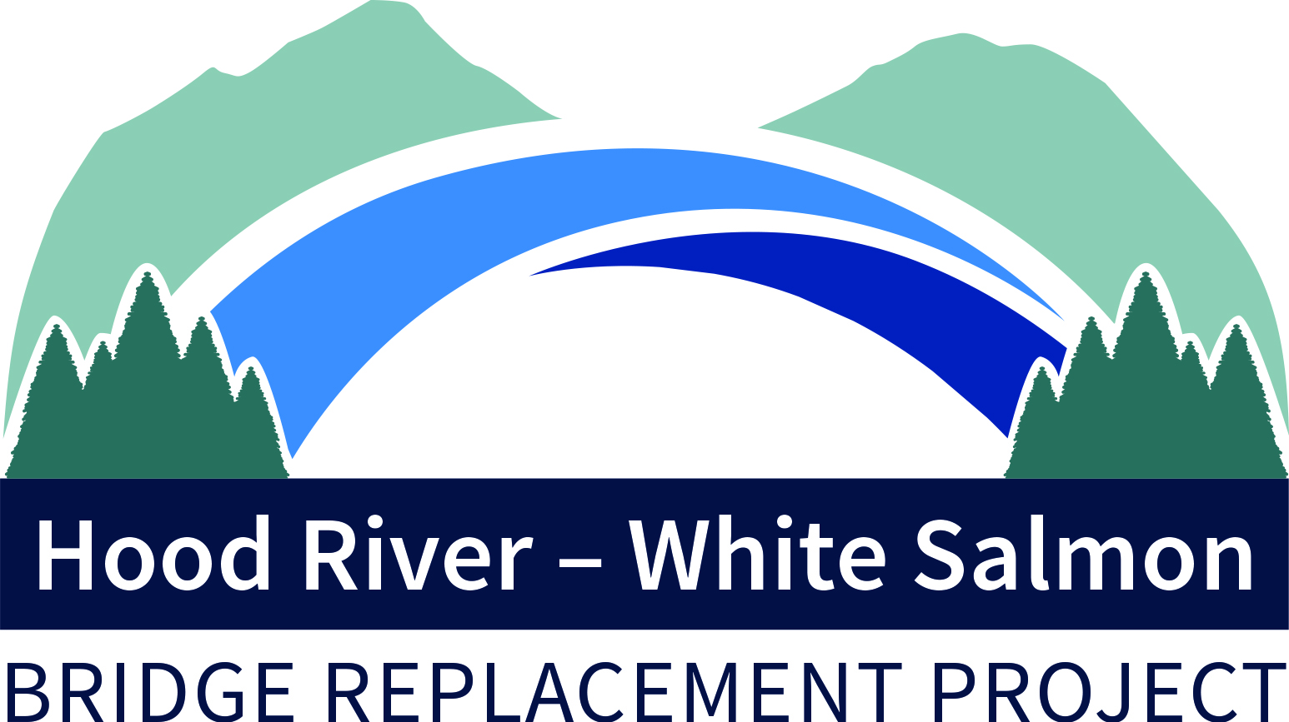
DRAFT AGENDA
Bi-State Bridge Replacement Working Group
Regular Meeting
June 13, 2022 / 2:00-4:00p
1000 E. Port Marina Drive, Hood River, OR

Members: Chair, Mike Fox (Commissioner), Port of Hood River; Vice Chair, Jake Anderson (Commissioner), Klickitat County; Catherine Kiewit (Mayor), City of Bingen; Marla Keethler (Mayor), City of White Salmon; Kate McBride (Mayor), City of Hood River; Bob Benton (Commissioner), Hood River County

Alternates: Kristi Chapman (Commissioner), Port of Hood River; Arthur Babitz (Commissioner), Hood River County; Joe Sullivan, City of Bingen; Jason Hartmann (Councilor), City of White Salmon; David Sauter (Commissioner), Klickitat County; Jessica Metta (Councilor), City of Hood River.

Staff/Consultants: Kevin Greenwood (Project Director), Port of Hood River; Michael McElwee (Executive Director), Port of Hood River; Dan Bates, Thorn Run Partners; Brad Boswell, Boswell Consulting; Hal Hiemstra, Summit Strategies; Steve Siegel Consulting

- Welcome 2:00
- May 13 Regular Meeting Minutes 2:01
- Government Affairs Contracts – Boswell, Bates, Hiemstra 2:02
- Federal Advocacy Trip - Hal Hiemstra 2:30
- Governance Update – Comm. Benton 2:35
- RBMC Negotiation Update – Comm. Fox 2:55
- 2022-23 Bridge Replacement Budget 3:00
- Grant Updates/Financial Reporting 3:10
- Project Updates/Other Items 3:20
- Next Meeting, June 20, 2022 3:30

-###-

Contact Kevin Greenwood, (541) 961-9517 or kgreenwood@portofhoodriver.com,
for Zoom credentials

