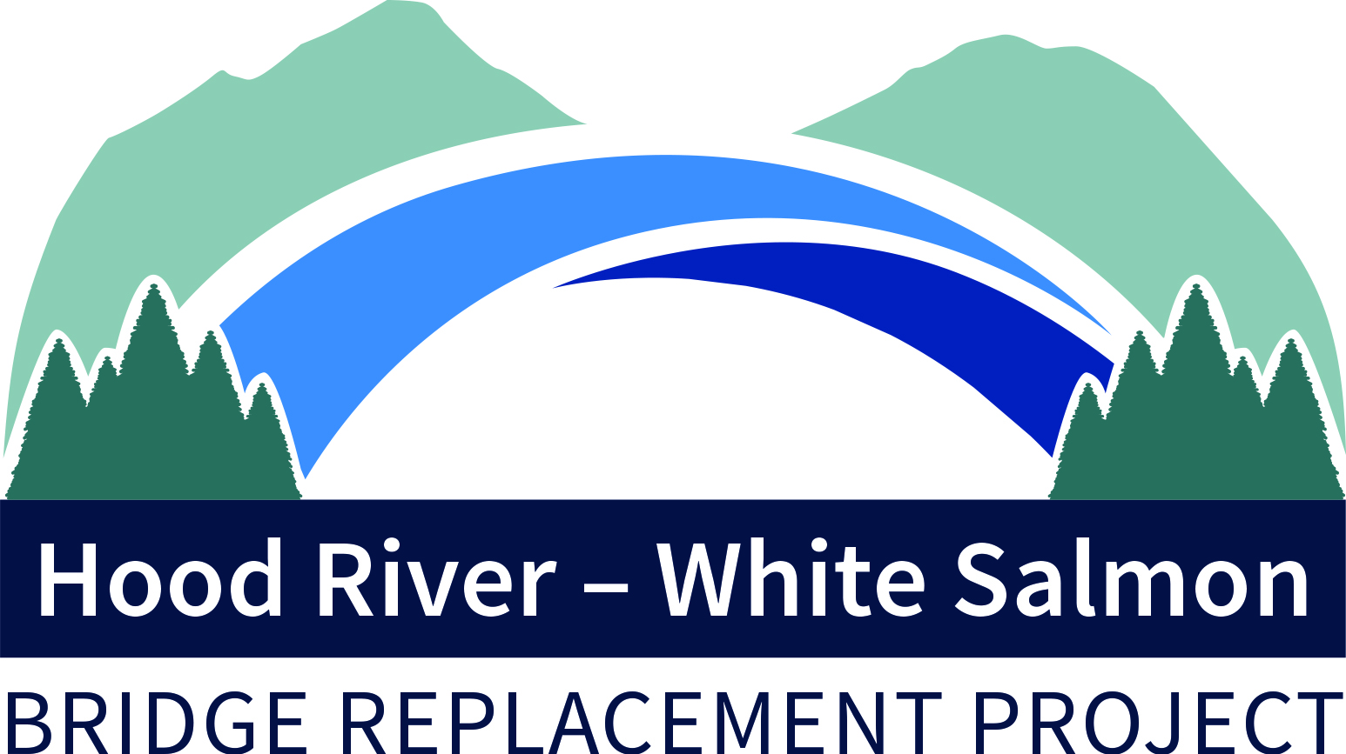
DRAFT AGENDA
Bi-State Bridge Replacement Working Group
Regular Meeting
August 15, 2022 / 2:00-3:00p
HNTB Project Office/Marina Park #1 Building
700 East Port Marina Way, Suite 201

Members: Chair, Mike Fox (Commissioner), Port of Hood River; Vice Chair, Jake Anderson (Commissioner), Klickitat County; Catherine Kiewit (Mayor), City of Bingen; Marla Keethler (Mayor), City of White Salmon; Kate McBride (Mayor), City of Hood River; Bob Benton (Commissioner), Hood River County

Alternates: Kristi Chapman (Commissioner), Port of Hood River; Arthur Babitz (Commissioner), Hood River County; Joe Sullivan, City of Bingen (Councilor); Jason Hartmann (Councilor), City of White Salmon; David Sauter (Commissioner), Klickitat County; Jessica Metta (Councilor), City of Hood River.

Staff/Consultants: Kevin Greenwood (Project Director), Port of Hood River; Genevieve Scholl (Interim Executive Director), Port of Hood River; Michael Shannon (Project Manager), HNTB; Steve Siegel, Siegel Consulting.

- Welcome 2:00
- July 11 Regular Meeting Minutes 2:01
- Commission Formation Agreements Update 2:02
A. Consensus for CFA Tax Implications Review
- Grant Opportunities 2:20
- $195M BIP Application Submitted
- SS4A Planning Grant
- Michael Shannon, HNTB 2:30
A. Schedule/Next Key Milestones
- Government Affairs 2023 Strategy 2:40
A. August 24, 2022 – Port Board Room
B. Federal Delegation Tour
C. Project Video
D. Field Rep Assignments
E. Speaker Notes
- Project Updates/Other Items 2:50
- Next Meeting, August 16, 2022 3:00

-###-

Contact Kevin Greenwood, (541) 961-9517 or kgreenwood@portofhoodriver.com,

