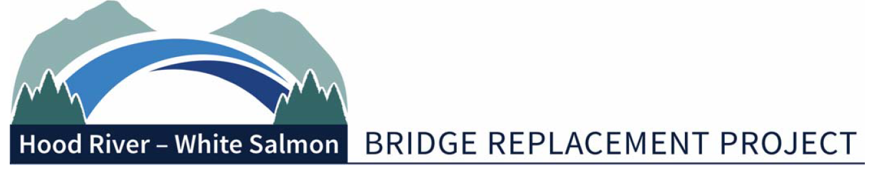
Bi-State Working Group Meeting Summary
Monday, August 15, 2022 | 2:00pm – 4pm
Port of Hood River – Commission Board Room & Via Zoom
1000 E Port Marina Drive, Hood River OR 97031
In Attendance:
Members: Chair, Mike Fox (Commissioner), Port of Hood River; Vice Chair, Jake Anderson (Commissioner), Klickitat County; Catherine Kiewit (Mayor - Excused), City of Bingen; Marla Keethler (Mayor), City of White Salmon; Kate McBride (Mayor), City of Hood River; Bob Benton (Commissioner), Hood River County

Alternates: Kristi Chapman (Commissioner), Port of Hood River; Arthur Babitz (Commissioner), Hood River County; Joe Sullivan, City of Bingen (Councilor); Jason Hartmann (Councilor), City of White Salmon; David Sauter (Commissioner), Klickitat County; Jessica Metta (Councilor), City of Hood River

Staff/Consultants: Kevin Greenwood (Project Director), Port of Hood River; Genevieve Scholl (Interim Executive Director), Port of Hood River; Michael Shannon (Project Manager), HNTB; Steve Siegel, Siegel Consulting.
Guests: Senator Curtis King, Adam Fiss, RTC
Welcome
Commissioner Mike Fox called the meeting to order at 2:00 p.m.
Meeting Minutes
The minutes from July 11 regular meeting were approved by consensus.
Federal Delegation Tour
Commissioner Fox noted that he attended the Washington DC trip with Commissioner Jake Anderson, Mayor Kate McBride, Mayor Marla Keethler, Kevin Greenwood, and Hal Hiemstra. The group met with several congressional offices. Overall Commissioner Fox believes the meetings went well with full support for the bridge replacement project. During their meeting with US Department of Transportation (USDOT), Morteza Farajian, Executive Director, expressed the opinion that a P3 approach would not be his recommendation since the project is a straightforward project. There was also a lot of discussion of several grant opportunities for the bridge replacement project. A TIFIA loan was also discussed and Farajian suggested that the Port should apply sooner rather than later. Commissioner Fox noted that they also met with the Department of Agriculture (USDA) which seemed like a viable secondary option for a loan, but TIFIA still would be the better option.
Draft Agenda – Government Affairs Strategy Workshop
Commissioner Fox reviewed the draft agenda for the government affairs workshop on August 24. The Bi-State Working Group (BSWG) and lobbyist will be meeting with state and federal delegates to discuss activities in the 2023 long session and the beginning of the 218th Congress.
HNTB Progress Report

Michael Shannon of HNTB, reported that they now have their office set up in the Marina Office building. HNTB has been meeting with WSP to get a better understanding of where they are in the process. They are also putting together design activities that will be presented to the BSWG in September. HNTB is also reviewing the permitting process and hoping to move it forward. Shannon thanked Sen. King for his efforts in obtaining the $75 million grant, HNTB is working to get that funding into the work plan. Sen. King commented that he looks forward to working with HNTB and offered his support.

Commission Formation Agreement Update
Commissioner Fox commented that at the last meeting with Federal Highway Commission, there was some concern regarding the new entity honoring prior agreements that were made by the Port of Hood River (“Port”). The recommendation was to add a clause to the agreement noting that the new bridge authority will honor past agreements if the BSWG has provided concurrence to the issue that the Port has approved. The BSWG consensus was to review the language once it was prepared.

Commissioner Fox turned to Steve Siegel of Siegel Consulting, for a brief update on the Commission Formation Agreement (CFA). Siegel commented that they are at the end of the draft one process and starting draft two. Currently no issues requiring major substantive change to CFA have been identified. Siegel commented that they are seeking approval from BSWG to subcontract with a Washington law firm to analyze differences in the WA sales tax incurred depending on location of principal place of business, and to review draft one CFA. The BSWG consensus was for HNTB to provide a recommendation as soon as possible on this matter and seek approval from the Port Commission as well.

Siegel noted that one of the key issues in the CFA is the composition of the Board. There are three voting members appointed by Klickitat County, and three voting members appointed by Hood River County, with nominations from participating governments. Both counties also will appoint Alternates to serve in lieu of the Director’s absence. One alternate can be appointed for each Director or one alternate for all three Directors. The BSWG consensus was to move forward with the proposed composition of the Board.

Siegel commented that the current CFA states that the co-chairs of the BSWG will serve as Ex Officio members of the Board until June 30,2025, unless extended by the Board. Ex Officio members are not voting members. The BSWG consensus was to move forward with the Ex Officio members as proposed in the CFA draft.

Siegel seeks direction on how to proceed with votes required to pass an ordinance. Siegel presented two options. Option A: requires at least four affirmative votes. Option B: requires an affirmative vote by a majority voting on the issue. The BSWG consensus was to proceed with Option A with refined language.

Grant Opportunities

Michael Shannon reported that the INFRA grant application for $195 million has been submitted. The Port may need to produce an “Action Plan” for Safe Street and Roads for All (SS4A) grant before applying for construction. HNTB is considering a joint application with the City of Hood River as they may be applying as well for the Heights project. BSWG consensus was to move forward with an Action Plan and to coordinate with City of Hood River, City of Bingen, and City of White Salmon. Shannon noted that HNTB has responded to several INFRA grant questions. This shows that they are still considering the replacement bridge project for the grant. HNTB has also responded to questions for the BUILD grant. Shannon is optimistic that they will obtain the BUILD grant.

Project Video – Bridge Closure

Mayor Marla Keethler presented a short video demonstrating what it was like when the bridge was closed. The BSWG would like to send the video to their contacts in Washington DC. The BSWG also suggested that more videos be made on safety and to document the progress of the project.

Field Rep Assignments

Commissioner Fox commented that he and Commissioner Kristi Chapman will make the assignments for the August 24 event. The BSWG requested a page of talking points.

Project Update

Kevin Greenwood reported that the Columbia interior branch chief rejected the Biological Opinion (BiOp) draft in July. The branch chief was advised not to sign due to formatting protocols. Shannon noted that the document has been sent to “Cindy” who will review the document and reach out the agency and provide insight to the Port.

Next meeting is on September 19. Commissioner Anderson asked for an update on the project design. Shannon commented that project design would require a supplemental agreement. HNTB will provide a recommendation in September on what design can be advanced.

Adjourn

Commissioner Fox adjourned the meeting at 3:58 p.m.

-###-

